APP SHELL (TOP BAR)
Surface: Creator App shell (top bar)
Observed Issue
- The labels “Hidden (1 hidden, 2 hidden, 3 hidden)” appear when the user unpins widgets.
Required Correction
- Remove the “Hidden” wording when widgets are unpinned.
Developer Notes
- Unpinned widgets should simply disappear or move to the widget manager without exposing system labels.

LANDING PAGE
Surface: Landing Page → Sign In Button
Observed Issue
- When the user taps Sign In, they are redirected to the “Continue to EVzone My Accounts” page and required to sign in again, resulting in a double authentication step.
Required Correction
- When a user taps Sign In, they should be redirected to https://accounts.evzone.app for authentication.
- For the current app state (not yet connected to EVzone Accounts):
- Users must be redirected directly to the dashboard after tapping Sign In.
Developer Notes
- Implement conditional routing logic based on EVzone Accounts integration status.
- Avoid duplicate authentication prompts in the interim flow.
- Ensure final production flow defaults to EVzone Accounts once integration is completed.

OPPORTUNITIES – Supplier Directory
Surface: Supplier Directory.
Observed Issue
- Supplier cards appear scattered and poorly arranged.
Required Correction
- Organize supplier cards in a structured and consistent layout.
Developer Notes
- Apply grid alignment and spacing rules for visual consistency.

IPHONE 13 OBSERVATIONS
SIGN IN -sign in with Evzone
Surface: Sign in with Evzone
Observed Issue
- Mobile version also redirects directly to the dashboard after account creation.
Required Correction
- Mobile users must be presented with a Sign In page after account creation.
Developer Notes
- Mobile and web authentication flows must remain consistent.

LIVE DASHBOARD-OPEN LIVE BUILDER
Surface: Mega Live Dealz-Products +consultation
Review & publish
Observed Issue
- The page keeps moving on the screen (UI instability).
Required Correction
- Fix layout shifting and page movement.
Developer Notes
- Investigate layout rendering and scroll anchoring issues

AD BUILDER
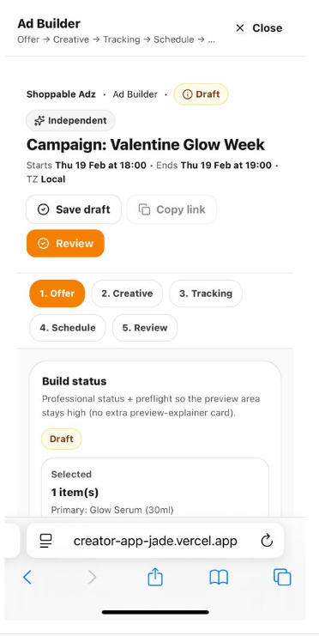
Observed Issue
- The highlighted card is sticky while the page scrolls behind it.
Required Correction
- Make the card scroll together with the page.
Developer Notes
- Sticky behavior should be removed.

ADZ DASHBOARD
Surface: Metric cards
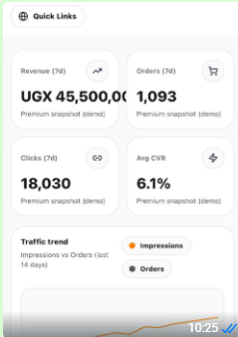
Observed Issue
- Metric amounts overflow outside the card boundaries.
Required Correction
- Ensure all figures are contained within the metric cards.
Developer Notes
- Apply responsive typography scaling and text wrapping rules.

MONEY & INSIGHTS
Surface: Side bar
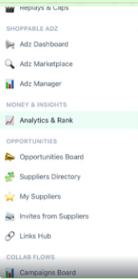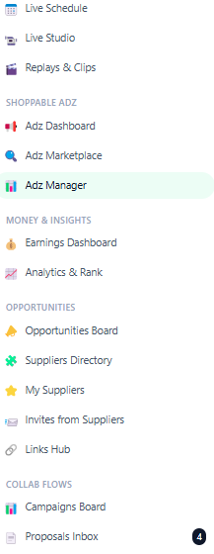

Observed Issue
- The Earnings Dashboard page is missing from the phone sidebar under Money & Insights.
- Phone sidebar differs from the web sidebar.
Required Correction
- Add Earnings Dashboard to the mobile sidebar under Money & Insights.
- Ensure sidebar parity between web and mobile.
Developer Notes
- Check device detection logic and responsive breakpoints.

NOTE: Ariho’s screen displays the same view of the phone despite using the same link. Please reach out to him and dicover why this is so. Note that this behaviour is only with his laptop.

